This guide is an installation instruction for StrateGIS database and StrateGIS Manager webapplication.

Prerequisites:
- Install SQL Server or SQL Server (Express) on your database server
- Install SQL Server Management Studio (SSMS) on your local client

Instruction, how to install StrateGIS database

- Download the complete install folder to your local drive
- In SSMS, create new database ‘StrateGIS’
- In SSMS run the ‘StrateGISManager_DB_installscript.sql’ script file – this will install all system tables and reference table for square_grid
- In SSMS run all scripts located in ‘install/stored procedures’ folder. Run the scripts in the numbered list order to avoid warnings.
- Run ‘Shape2Sql.exe’ in the ‘install/sqlspatial tools’ to import the file ‘install/ square_grid.shp’
  - this tool has dependencies for SQL Server 10.5.x – please note ‘SqlServerSpatial.dll’ and ‘Microsoft.SqlServer.Types.dll’ for that version are located in the same folder.
  - Regarding sqlspatial tools
    - Requirements: ‘Microsoft .net framework 3.5 (including .NET Framework 2.0 and 3.0)’
    - Please read this thread: https://gis.stackexchange.com/questions/221417/importing-shapefile-geometry-into-sql-server-2016 – especially this: ‘I use a free tool, shape2sql.exe, by SharpGIS.net. Because the tool is unmaintained you may need to copy and rename a dll, SqlServerSpatial110.dll or SqlServerSpatial120.dll to SqlServerSpatial.dll in C:\windows\system32. Also, clear out field "ID Column Name" for the data to import, I'm on Win10 64 bit.’
    - In the SharpGIS directory, Install ‘Microsoft.SqlServer.Types’, version 10.5.x from this link: https://www.nuget.org/packages/Microsoft.SqlServer.Types/10.50.1600.1
- Fill out the properties and select ‘Upload to Database’
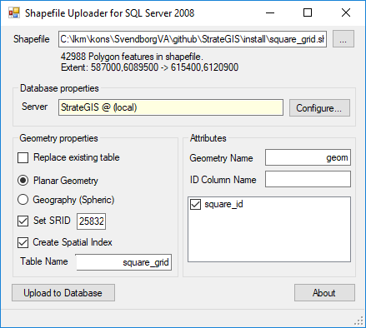

Installation is complete and StrateGIS database is ready for use

Instruction, how to install StrateGIS Manager webapplication

